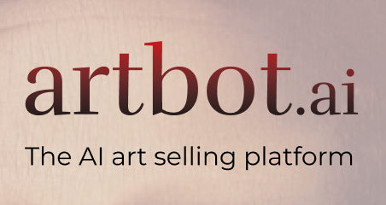

***Introduction***

Thanks to an amazing job from our technical team, we developed an integration of a visual recognition combined with a customized chatbot. Our product is able to find the artistic movement and more from a given picture of a piece of art.

We were looking for concrete business applications to this technology.

* The first obvious one we found was a new way to design the audio tour in museums or galleries. We could have used our visual recognition to identify the paintings and delivered information about it with our chatbot. But we wanted to build a business product that does not require a partnership, with a company or institution such as famous museums, to be effective. Furthermore, our product was not that much different from what is done actually in famous museums.
* We also thought to build an app that, given a painting picture, shows the customer how to travel and visit it (travel leads with art as the motivation).

Nonetheless we realised that it does not answer to a true need and give a poor use of our technology. We also wanted to focus on the art market and definitely not on the travel one.

Thus, we decided to dive deeply in the art estimation market and to imagine how our technology could disrupt it.

***Problem Statement and presentation of our solution***

My friend Henri just came back from a week-end at this grandparents’ place. And he discovered hidden paintings. He has no clue who painted it, from which movement does it came from and also what is its value on the market. How could he collect rapidly this information? Can we really trust anyone? And if I want to sell it where to go?

That’s why we came up with a brand-new designed solution. Indeed, we want to develop a comprehensive web application that gives you an estimation of your painting when you send a picture to it. The application will also give some insights about the painting (movements, maybe author, …) when you send the painting. Indeed, you interact with a chatbot that gives you all the information you’ll need. We also offer an art selling platform, where you can sell your estimated piece of art. The estimation if free of course if you sell your painting on our platform. Otherwise, you’ll have to pay for it.

***Methodology and technical development***

The first step was to develop and train our visual recognition system. We used the Watson vision recognition tool and we trained it on 10 movements:

* Rococo
* Futurism
* Baroque
* Classicism
* Impressionism
* Cubism
* Renaissance
* Modern Art
* Romanticism
* Expressionism

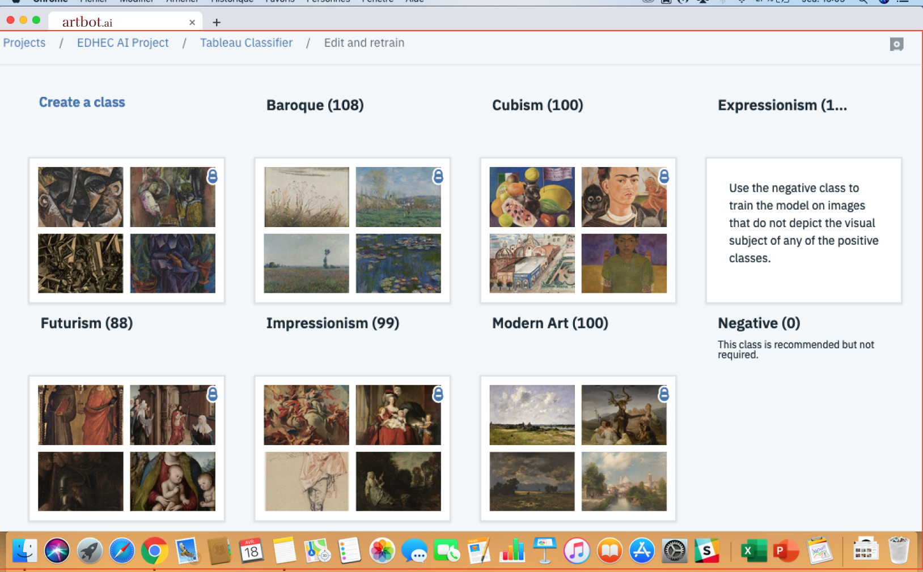

We gave 100 pictures of paintings par movement; thus the tool was trained with 1,000 paintings. And at the end it was able to recognize pretty well the different movement.

The second step was to develop the chatbot that will interact with the customer. We used the Watson Assistant and trained it with entities and intents written on csv files. The Assistant is in charge of the dialog with the user, to smooth the experience of evaluating and estimating his painting.

To collect information on the movements or the artist, we also developed an Python API that scraps directly from Wikipedia the information needed.

The last part was to integrate everything. We used Node-Red to create an integrated chatbot in Messenger. Hence Node-Red listen to Messenger and treat accordingly the user’s request. Send his text message directly to the chatbot, send the image to Visual Recognition or call an API if the user’s request ask it.

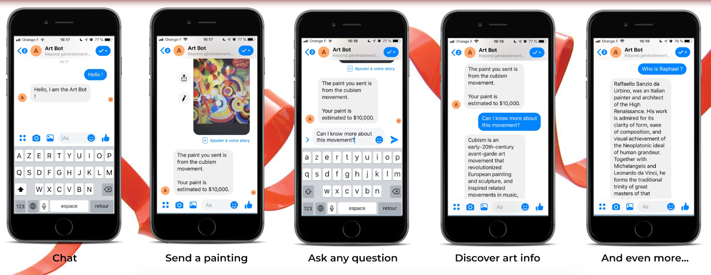

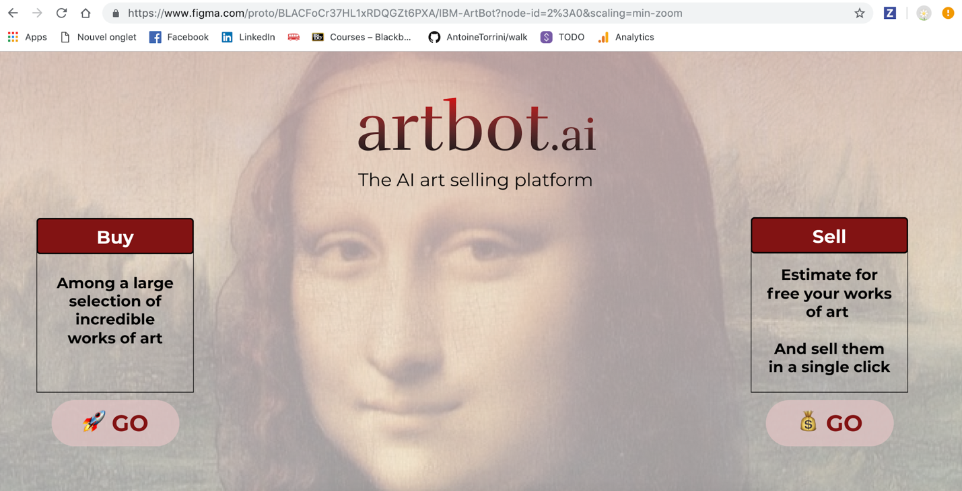To do a simulation of our web application we used Figma to model how it would look like.

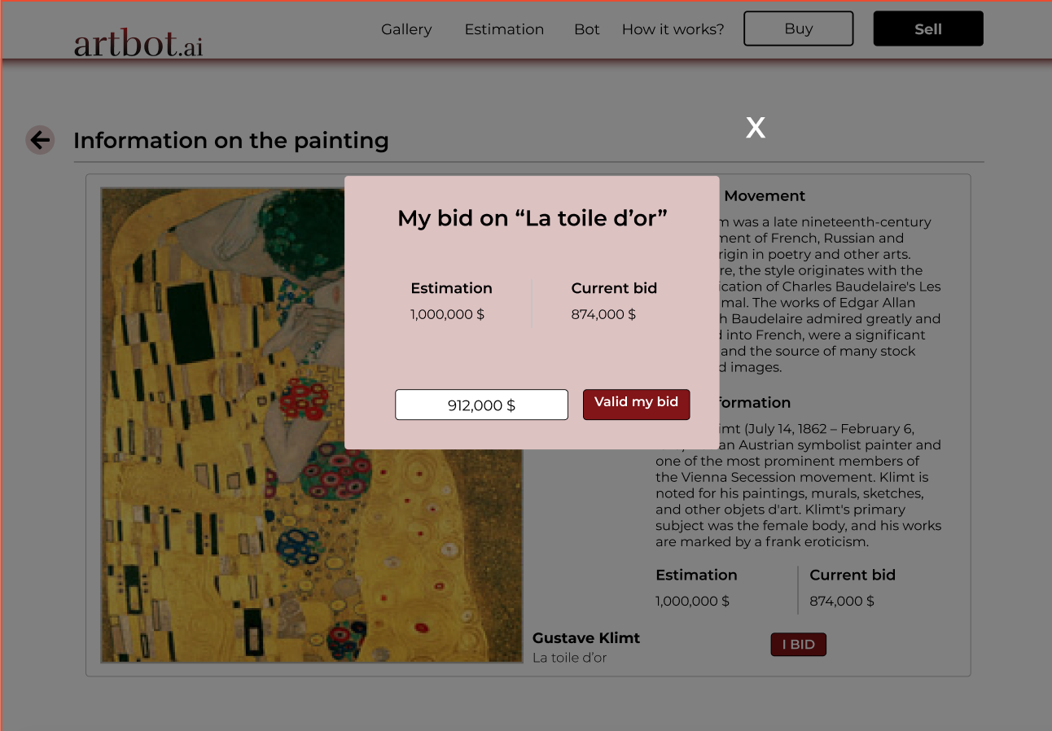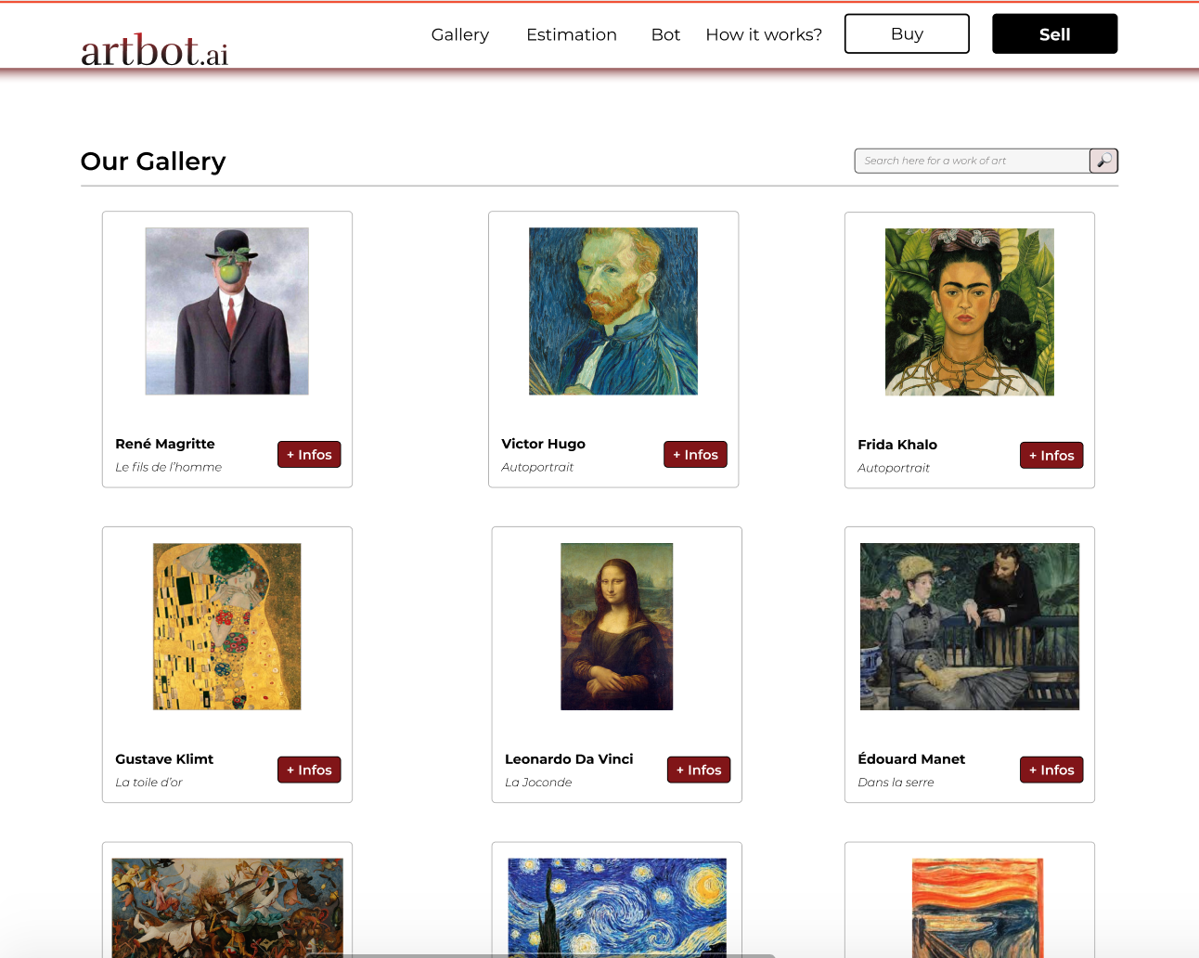

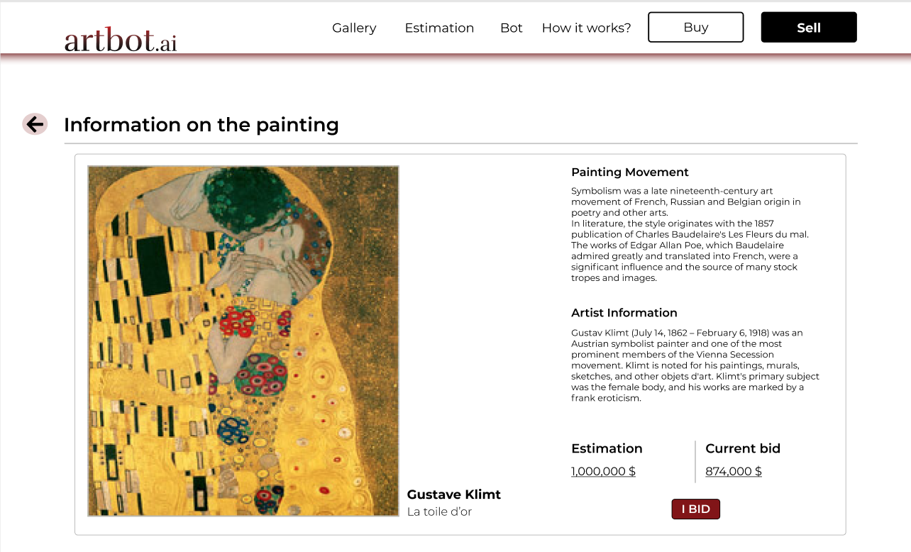

**Code Pattern of Actual Product**

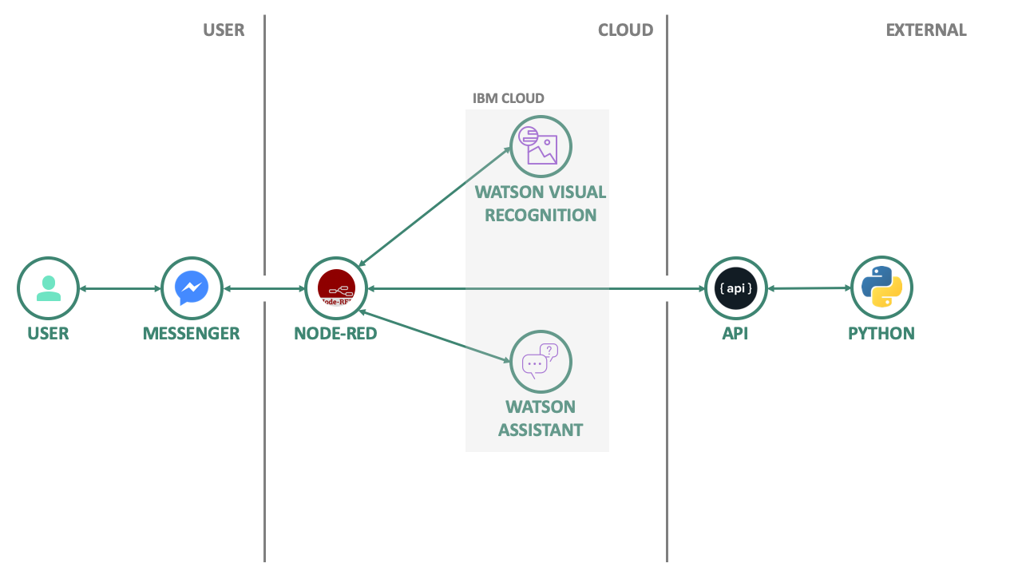

To develop a proper working application, we would of course to train both the visual recognition and the chatbot with thousands of paintings. Our business idea is that our AI would also grow and improve itself with new customers. The bigger will be our painting database the better will our AI application be. On the estimation, we could train a neural network to estimate the selling price of a painting according to the signature, the movement, the artist, the color and the state of the painting.

**Desired Code Pattern**

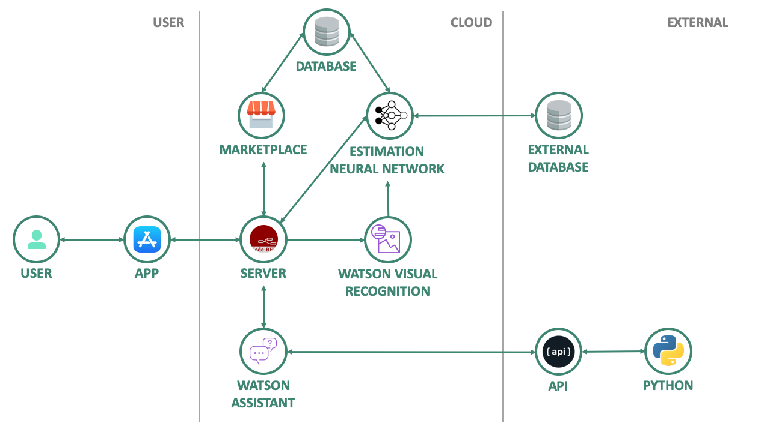

***Findings***

As a short reminder of the current art market state:

* Art transactions represent 51,3 billion € in volume in 2018 (UBS estimation)
* In twenty years, a growth of 456 % boosted by new actors such as Chinese customers

As we mentioned it in the problem statement, lots of piece of arts regular owners do not know this market. It can be scary to risk yourself to sell or buy an object on an unknown market.

Today, there are no alternatives to the classical scheme when it comes to estimate a painting in order to sell it. Indeed, you have to contact an expert (found on a dedicated website poorly designed with unfriendly UX or by yourself) to have an idea of the value and then sell it to the auctions.

We want to disrupt that model. We are convinced that we could claim a part of the art market big’s cake.

Either if you are a buyer or a seller, a regular or a professional, our solution is well-fitted to an art sales related issue.

Our platform proposed a user-friendly way to estimate, sell or buy pieces of art.

For estimation issues:

Our platform provides you an estimation (based on AI and expert intervention to confirm it) of your paintings. If you are willing to sell it on our platform, it is free. Conversely, you have to pay for the estimation (price of the expert plus platform fees).

For selling issues:

Our platform is a marketplace to ease the supply/demand interaction, both for regulars and professionals. If you already have an estimation of your painting’s value, the platform will take care of the auctions with a fixed deadline and minimum amount the users have indicated. The platform will take commission fees.

For buying issues:

You use filters to display the paintings you are interested in. Of course, you can’t directly reach the seller before the auction comes to an end.

All this information considered, the platform will have two main revenues channels :

* Estimation fees
* Sales fees

We want this fees to be large enough to support the platform’s growth but small enough to encourage owners and buyers to use it instead of feeding the classical scheme.

In the early stage of the platform’s development, we would like to focus on several key metrics such as :

* **traffic** (Number of visits on the website)
* **estimation conversion rate (**Number leads to estimation / Number of visits)
* **sales conversion rate (**Number leads to sales / Number of visits)
* **estimation margin (**Sum fees on estimations / sum estimations values)
* **sales margin (**Sum fees on sales in average / sum sales values)
* **cost of an estimation (**Cost of an expert / estimation)
* **growth capacity (**Number of an expert available / Number of expertise required)
* **platform sales conversion (**Number estimation paid / Number of estimation made)

***Discussions***

As explained above, we will monetize our model thanks to two fees : the estimation and sales fees. On a legal statement you have to be certified as auctioneer to sell paintings. We would then hire a consultant to get the right to sell paintings on our platform. We did not consider to monetize the website thanks to advertisement. Indeed, it could jeopardize the user experience that is of paramount importance for us.

In the future, our model could also expand rapidly and create value differently. We have several strategies. When the technology would be properly trained we can sell it to several entities: museums, art gallery or even auction companies to ease their work and increase their efficiency.

Besides in terms of technology to get the perfect recognition tool we could also train it with signature recognitions. It would allow us to match even better the current art market.

***Appendices***

Github folder:

<https://github.com/AntoineTorrini/Project-EDHEC-AI>